Preface: The origin of this document.
When I first started doing genealogy research I would regularly find family histories on the web but they had no documentation. They did not say who did the research or what documentation they found to confirm their findings. That was frustrating and therefore, I document my findings.

I (Matthew Mark Fletcher of Detroit MI) was looking for genealogy information on the web. I came across the website http://www.fialcowitz.com/ It is run by Ann Fialcowitz who is a apparently a distant cousin of mine. She sent me the genealogy document below called Descendants of Thomas Fletcher. When I asked Ann where the document came from, she did not answer. I sent her several e-mails asking about the origin of the document and she never answered back. I asked about the origin of the document because I saw a report on the news that said some genealogy researchers simply make up facts and then give them to the people that hired them. That is why I would like to verify as much as possible but, I do not know exactly how accurate the document it. My own research on the family line of Thomas Fletcher seems to indicate that it is pretty accurate and I plan to put in on a website with other Fletcher information.

This document ends (leads to) the “Children of Laura Jackson and William Robinson” on the last page. I imagine they created or had a genealogy researcher do it for them. I would like to talk to them if anyone out there knows how to contact them.

I have done my own research on the web and interviewed family members and made changes to this document. Everything in RED was added by me. Wilson Fletcher was NOT shown to be a son of Henry Fletcher in the original document given to me by Ann Fialcowitz. I believe Wilson is the son of Henry, I have census documents showing that, and I added Wilson and all his known descendents leading to me. It is not unusual for a child to be left off in a document like this. Some kids are simply forgotten about because they moved away, were forgotten about or overlooked by the person making the genealogy document. I have seen original census documents that show Henry Fletcher having a son named Wilson and that Wilson had a son named William (Wm.) William is my grandfather. They all have the right name, were the right age and were from the right place and that is why I believe Wilson is the son if Henry. I have not been able to finding anything on Thomas Fletcher. I would like to find something linking Henry and Thomas.

I exchanged e-mails with Frances Howard Hickey who is a 75 year old third cousin I found on the web. Frances seems pretty confident about certain facts and says that Wilson Fletcher came to Clay Co. KY from Hancock Co. TN to care for his sisters children when the sister died. One of the children that Wilson cared for was the grandmother of Frances Howard Hickey. I saved Frances’ e-mails if anyone is interested in reading them. Also, my aunt Amanda Fletcher Keith was able to confirm many of the facts in the later generations and remembered several of the people linked to Pete House.

Also, I had my DNA tested and compared to other Men with the surname Fletcher. I matched several but none of them led back to Thomas Fletcher below. Instead, they lead back to a Moses Fletcher (see the “Moses Fletcher line”). This does not necessarily mean that the Thomas Fletcher document is incorrect. Thomas and Moses could be cousins, brothers, uncle and nephew.

Matt Fletcher. 18450 Meier Roseville MI 48066 December 2007

FLETCHER



A maker of arrows, or superintendent of archery. From the French flèche, an arrow. The feather on the shaft of an arrow is called the fletching.

Descendants of Thomas Fletcher

Generation No. 1
- Thomas 1 Fletcher He married Catherine ?. She was born 1793 in Virginia. (note: My DNA was linked to a Moses Fletcher through Richard Fletcher who lives in DE. He is a retired engineer and has been researching the Fletcher line for 40 years. Our DNA matches 67 of 67 markers. Moses was married to a woman who was reportedly born in 1725, so Moses was probably born about the same time or earlier. No known records show Moses having a son or brother named Thomas. - Matt Fletcher 2007)

Child of Thomas Fletcher and Catherine ? is:
+ 2 i. Henry 2 Fletcher, born 1812 in Tazwell, Virginia; died in Hancock County, Tennessee.

Generation No. 2
2. Henry 2 Fletcher (Thomas 1 ) was born 1812 in Tazwell, Virginia, and died in Hancock County,
Tennessee. He married Celia Bunch in Hancock Co., Tennessee, daughter of Benjamin Bunch and Mary
Dotson/Dodson. She was born 1812 in North Carolina.

Children of Henry Fletcher and Celia Bunch are:
3 i. Catherine 3 Fletcher, born 1838.
4 ii William Fletcher, born 1839.
5 iii. Wilson Fletcher, born 1841 in Hancock County, Tennessee; died in Clay County, Kentucky. I added Wilson here because I have a screen print of a census document showing that Henry had a son named Wilson. Ages, time, place all match.
6 iv. Mary Ann "Polly" Fletcher, born 1848 in Hancock County, Tennessee.
7 v. Benjamin Fletcher, born 1847 in Hancock County, Tennessee. He married Harriet Pridemore.
8 vi. John Jesse Fletcher, born 1850 in Hancock County, Tennessee; died 1937 in Lee County, Virginia. He married Phebe E. Weston.
9 vii. Amanda Jane Fletcher, born 1854 in Hancock County, Tennessee.

Generation No. 3
5. Wilson 3 Fletcher (Henry 2 , Thomas 1 ) was born 1841 in Hancock County, Tennessee, and died 1916 in Clay County, Kentucky. He married Mary "Polly" Johnson.

Children of Wilson Fletcher and Mary Johnson are:
+ 10 i. Martha Fletcher, born July 1870 in Tennessee; died Abt. 1914 in Clay County, Kentucky.
+ 11 ii William Fletcher, born ????????? in Tennessee; died ????????? in Clay County, Kentucky. Wilson (my great grandfather) had a son named William (my grandfather).

6. Mary Ann "Polly"3 Fletcher (Henry 2 , Thomas 1 ) was born 1848 in Hancock County, Tennessee. She
married Andrew Johnson in Hancock County, Tennessee, son of Jonathan Johnson and Jane Bloomer. He was born March 27, 1847 in Kyles Ford, Hancock County, Tennessee, and died December 27, 1925 in Kyles Ford, Hancock County, Tennessee.

More About Andrew Johnson:
Burial: Davis Chapel Cemetery, Hancock County, Tennessee
Occupation: Baptist Minister

Children of Mary Fletcher and Andrew Johnson are:
+ 11 i. John Jesse 4 Johnson, born October 25, 1872 in Kyles Ford, Hancock, Tennessee; died September 15, 1943 in Lynch, Harlan, Kentucky.
+ 12 ii. Tivis Johnson, born May 29, 1875; died May 23, 1960 in Harrogate, Claiborne, Tennessee.
13 iii. Laura Johnson, born 1877 in Kyles Ford, Hancock County, Tennessee; died February 02, 1959. She married Wesley Johnson.
+ 14 iv. Henry "Bud" Johnson, born May 18, 1881 in Kyles Ford, Hancock County, Tennessee; died July 10, 1964 in Kyles Ford, Hancock County, Tennessee.

9. Amanda Jane 3 Fletcher (Henry 2 , Thomas 1 ) was born 1854 in Hancock County, Tennessee. She married Zachriach Jackson, son of Benjamin Jackson and Hetty Helton.

Children of Amanda Fletcher and Zachriach Jackson are:
+ 15 i. Laura Jane 4 Jackson.
16 ii. Florence Jackson.

Generation No. 4

10. Martha 4 Fletcher (Wilson 3 , Henry 2 , Thomas 1 ) was born July 1870 in Tennessee, and died Abt. 1914 in Clay County, Kentucky. She married Peter "Pete" House July 16, 1891 in Clay County, Kentucky. He was born August 1869 in Greensburg, Decatur, Indiana.

More About Martha Fletcher:

Burial: Manchester, Clay County, Kentucky

Children of Martha Fletcher and Peter House are:
17 i. Beve Prior 5 House, born May 10, 1892 in Clay County, Kentucky; died August 02, 1952 in Hamilton,
Butler, Ohio. He married (1) ? Mullins. He married (2) Emma Allen December 22, 1911 in Clay
County, Kentucky.

More About Beve Prior House:
Occupation: worked for Champion Paper Company in Hamilton,Ohio

18 ii. Daisy House, born February 27, 1894 in Clay County, Kentucky; died January 24, 1974 in Clay County,
Kentucky. She married George B. Horton October 12, 1912 in Clay County, Kentucky.
19 iii. James House, born April 1896. He married Amelia White December 04, 1915 in Clay County,
Kentucky.
20 iv. Lester House, born October 12, 1898 in Clay County, Kentucky; died April 05, 1976 in Hamilton,
Butler, Ohio. He married Sally Lunsford June 18, 1923 in Clay County, Kentucky; born Abt. 1900.
21 v. Mary House, born October 28, 1900 in Clay County, Kentucky; died July 10, 1922 in Clay County, Kentucky. She married David Lloyd Hyde.
22 vi. Alda House (according to my aunt Amanda Fletcher Keith ) House. She married Bradley Hyde.
23 vii. Jailey House, born March 01, 1906 in Clay County, Kentucky; died May 23, 1979 in Clay County, Kentucky. She married (1) Joe Steele; born August 26, 1899 in Pittsburg, Laurel, Kentucky. She Married (2) ? Gilbert.
- viii. William Jennings House, born February 18, 1909 in Clay County, Kentucky; died May 12, 1958 in Cincinnnati, Ohio. He married Nora Johnson; born August 14, 1914 in Corbin, Kentucky.

11. William Fletcher (Wilson 3, Henry2, Thomas 1 was born ????? in TN and died ????? in Clay Co. KY. He married Myrtle White ????? in Clay Co. KY. Myrtle was born ????? in Clay Co. KY.

More About William (W.m.) Fletcher:
Burrial: Manchester, Clay County, KY in Fletcher cemetery, on Pennington Road. He married Myrtle White born ???????, Died ??????; of Clay County Kentucky. William and Myrtle had 12 children. All were born in Clay Co. KY.

Children of William Fletcher and Myrtle White are:

- Catherine Fletcher, born 9-25-1915, died 2-1-1938 Clay County Kentucky. Died from burns received when her nightgown caught on fire while warming her self in front of the fireplace. Buried Clay County Kentucky in Fletcher Cemetery on Pennington Hill Road.

- Pearl Fletcher,
iii. Beve Fletcher,
iv. Mable Fletcher

v. Charles Fletcher, born 1-6-1921, in Clay County Kentucky; died 3-4-1953. Burried in Fletcher cemetery on Penninton Hill Road, Manchester KY. Wife Nancy Olga Fletcher B: 4-14-1918, D 12-10-2002, Also buried in Fletcher cemetery.
Buried Clay County Kentucky in Fletcher Cemetery on Pennington Road.

vi. Amanda Fletcher Keith. Married Burt Keith and lives in Hamilton Ohio.

vii Marie Fletcher. B 1922, D 1984 of Lupus. Married John Crawford of Clay Co. KY
viii. Matt Fletcher , born May 27, 1927 Clay County Kentucky; died September ?? 1993 ??Detroit Michigan. Buried Clay County Kentucky in Fletcher Cemetery on Pennington Road.

ix. William (Nunu) Fletcher

x. Josephine Fletcher, born 1934, died 1986?? Clay County Kentucky; died of lupus Clay County Kentucky. Buried in Manchester Kentucky in Fletcher Cemetery on Pennington Road.

xi. John Crit Fletcher. Lives in Corbin Kentucky, retired school teacher, no children.

xii MaryAnna

More About Matt Fletcher: came to Detroit after ww2 for work. Occupation-residential and commercial painter. WWII vet, married Wilma Jaree Sanders of Knox County KY, daughter to Charles Sanders and Louise “Lou” Henson. Louise Henson Sanders was the daughter of Sally and Bo Henson. Matt and Wilma Fletcher had 4 children: Linda, Sandra Dee, Mathew Mark and Michael David Fletcher. All Born Detroit Michigan.

More about William Fletcher. Occupation- autoworker, WWII vet, married Dessie Wynn of Knox County KY. Had 2 children, Doug and Unis.

.........

11. John Jesse 4 Johnson (Mary Ann "Polly"3 Fletcher, Henry 2 , Thomas 1 ) was born October 25, 1872 in Kyles Ford, Hancock, Tennessee, and died September 15, 1943 in Lynch, Harlan, Kentucky. He married Eliza Jane Johnson 1900 in Hancock County, Tennessee, daughter of Alexander Johnson and Sarah Livesay. She was born October 18, 1884 in Lee County, Virginia or Hancock County, Tennessee, and died February 14, 1929 in Big Stone Gap, Virginia.

More About John Jesse Johnson:
Burial: September 17, 1943, Big Stone Gap, Wise, Virginia

Children of John Johnson and Eliza Johnson are:
25 i. Nedlene 5 Johnson, born January 29, 1923 in Big Stone Gap, Virginia; died September 01, 1947 in Madison County, Indiana. She married M Rex Renner; born September 28, 1918 in Hamilton County, Indiana.
26 ii. ? Johnson.
27 iii. ? Johnson.
28 iv. ? Johnson.
29 v. ? Johnson.
30 vi. ? Johnson.
31 vii. ? Johnson.
32 viii. ? Johnson.
33 ix. ? Johnson.
34 x. ? Johnson.
35 xi. ? Johnson.
36 xii. ? Johnson.
37 xiii. ? Johnson.
38 xiv. ? Johnson.
39 xv. ? Johnson.
12. Tivis 4 Johnson (Mary Ann "Polly"3 Fletcher, Henry 2 , Thomas 1 ) was born May 29, 1875, and died May 23, 1960 in Harrogate, Claiborne, Tennessee. He married Lizzy Pridemore.

More About Tivis Johnson:
Burial: Davis Chapel Cemetery, Hancock County, Tennessee
Child of Tivis Johnson and Lizzy Pridemore is:
40 i. ? 5 Johnson.

14. Henry "Bud"4 Johnson (Mary Ann "Polly"3 Fletcher, Henry 2 , Thomas 1 ) was born May 18, 1881 in Kyles Ford, Hancock County, Tennessee, and died July 10, 1964 in Kyles Ford, Hancock County, Tennessee. He married Cilia Ann Johnson.

More About Henry "Bud" Johnson:
Burial: Davis Chapel Cemetery, Hancock County, Tennessee
Children of Henry Johnson and Cilia Johnson are:
41 i. ? 5 Johnson.
42 ii. ? Johnson.
43 iii. ? Johnson.
44 iv. ? Johnson.
45 v. ? Johnson.
46 vi. ? Johnson.
47 vii. ? Johnson.
15. Laura Jane 4 Jackson (Amanda Jane 3 Fletcher, Henry 2 , Thomas 1 ) She married (1) William Claudius Robinson. She married (2) William Claudius Robinson, son of Leander Robinson and Nancy Robinson.

More About Laura Jane Jackson:
Burial: River Hill Cemetery

Children of Laura Jackson and William Robinson are:
- i. Florence 5 Robinson, born December 02, 1897 in Jackson County, Kentucky; died December 19, 1975 in Laurel County, Kentucky. She married (1) William Otis Howard; born July 21, 1898 in McWhorter, Laurel, Kentucky; died December 25, 1955. She met (2) Roscoe Schoonover. She married (3) James Wathen; born January 22, 1897; died July 25, 1969.

More About Florence Robinson:
Burial: River Hill Cemetery

More About James Wathen:
Burial: Wathen Cemetery, Laurel County, Kentucky

- ii. Humana Robinson. She married ? Greer.

More About Humana Robinson:
Burial: River Hill Cemetery

- iii. Kellon Robinson.

More About Kellon Robinson:
Burial: River Hill Cemetery

End of Thomas Fletcher Document

Everything from here down was collected and added by Matt Fletcher
12/15/2007)
The chart below is from
http://www.genealogy.fletcher.net/

•Moses Fletcher of Fauquier County, Virginia (formerly known as Wm of Montgomery line)
http://www.genealogy.fletcher.net/

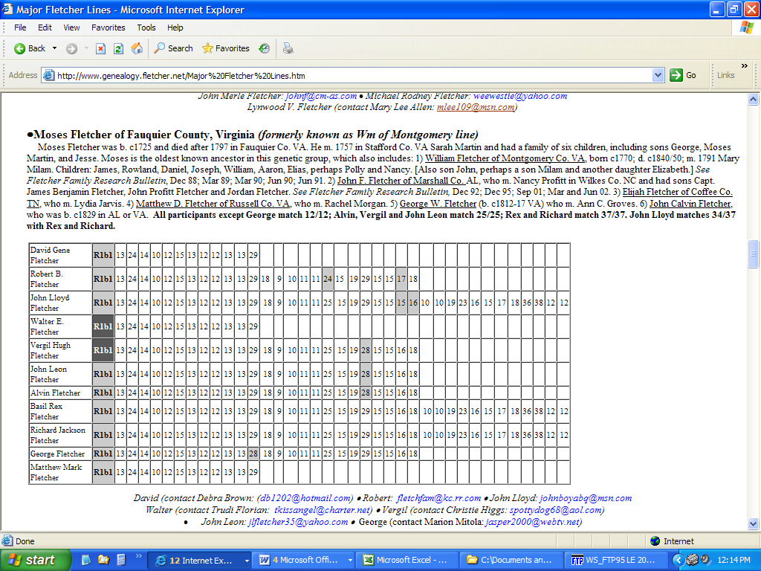

Above is information completely separate from the Thomas Fletcher document.
I took a DNA test and the results showing other Fletcher that I/we match. This test is done using male DNA that is passed down virtually unchanged generation to generation and there is a 99% chance we are related. We can only confirm for certain that we are related to the other people tested. The other information leading back to Moses is based on the family history of one of the people I/we are related to above. I have not figured out who in the group says they are descended from Moses Fletcher

We have DNA matches all over the world but most come from England, Ireland and Scotland.

Exact Matches to my 12 marker DNA (most basic test) are probably relatives from hundreds of years ago or less. More exact matches in Ireland than England. So, our Fletchers may have gone from England to Ireland, the to America.
British Isles (772) | - | 1
England (13725) | - | 2
Great Britain (910) | - | 1
Ireland (7529) | - | 13
Netherlands (729) | - | 1
Russia (2148) | - | 1
Scotland (6065) | - | 1

One Step Mutations (like George Fletcher on page one. One digit in there is different from mine. They are still related to us but probably farther back in time…many hundreds or thousands of years ago.)
Austria (266) | - | 1
Belgium (290) | - | 1
British Isles (772) | - | 1
Czech Republic (169) | - | 1
England (13725) | - | 22
France (1808) | - | 2
Germany (6308) | - | 5
Iceland (133) | - | 1
Ireland (7529) | - | 10
Netherlands (729) | - | 1
Northern Ireland (350) | - | 1
Norway (700) | - | 2
Scotland (6065) | - | 9
Spain (1652) | - | 1
United Kingdom (4438) | - | 3
United States (821) | - | 3

Three step mutations. Three numbers in their DNA are different from mine. Probably related related but even farther back in time. Several thousand years ago. Sometimes DNA matches by pure coincidence since there is a limited number of combinations.

Austria (266) | - | 1
Bahamas (20) | - | 1
Belgium (290) | - | 3
Bohemia (98) | - | 1
Brazil (33) | - | 2
British Isles (772) | - | 9
Canada (107) | - | 2
Canary Islands (57) | - | 1
Colombia (65) | - | 1
Cuba (70) | - | 2
Denmark (482) | - | 2
England (13725) | - | 131
Finland (634) | - | 3
France (1808) | - | 20
Germany (6308) | - | 36
Great Britain (910) | - | 13
Greece (405) | - | 1
Greenland (62) | Inuit (European admixture) | 3
Haiti (8) | - | 1
Holland (173) | - | 2
Iceland (133) | - | 1
Ireland (7529) | - | 70
Italy (1675) | - | 5
Lithuania (532) | - | 1
Luxemburg (23) | - | 1
Netherlands (729) | - | 5
Netherlands (729) | Ashkenazi-Levite | 1
Northern Ireland (350) | - | 2

Continued

Norway (700) | - | 4
Portugal (330) | - | 3
Prussia (229) | - | 1
Puerto Rico (149) | - | 2
Scotland (6065) | - | 55
Senegal (80) | - | 1
Sicily (228) | - | 2
South Africa (92) | - | 1
Spain (1652) | - | 5
Spain (1652) | Andalusia | 1
Sweden (971) | - | 2
Switzerland (887) | - | 3
Turkey (193) | - | 1
United Kingdom (4438) | - | 41
United States (821) | - | 3
Wales (1132) | - | 20
Yugoslavia (44) | - | 1

Below are some screen prints of documents I found online

Kentucky Death Records

2,921,383 records from 1911 thru 2000

Results 1-1 of 1
Last Name | First Name | MI | Age | Death Place | Residence | Death Date | Volume | Certificate | Death Volume | Post-ems
FLETCHER | WILSON |  | 067 | CLAY |  | 11-26-1916 | 056 | 27592 | 1916 | Add

Top of Form
Last Name
First Name
Place of Death
Residence
Year

This shows that Wilson Fletcher (son of Henry) of Hancock County TN died in Clay county KY. My aunt Pearl or Mabel told me that he is buried in the Fletcher cemetery on Pennington Hill Rd. in Manchester KY. Pearl and Mabel were two of my dad’s oldest sisters and none of the younger kids ever heard that Wilson was buried on the hill. Only a rock marks the grave so I wonder if Wilson really is buried there. No writing on the rock. If this is Wilson’s grave, where is his wife buried? What year did his wife die? Check on this!!!! Find Polly and Wilson may be buried next to her.

http://ftp.rootsweb.com/pub/usgenweb/tn/hancock/census/1860/idx-cr-h.txt

This link was given to me by Francis Howard Hickey. Wilson Fletcher is shown in the data below at age 19. I believe Wilson is the Son of Henry –Matt Fletcher 12/14/2004

Hancock, TN 1860 Federal Census - Index File 2 - cr-h

This Census was transcribed by Sharon Fultz Patterson, sharopt@worldnet.att.net
and proofread by Richard M. Patterson for the USGenWeb Census Project, http://www.usgenweb.org/census.

Copyright 1999 by Sharon Fultz Patterson, sharopt@worldnet.att.net

************************************************************************
USGENWEB NOTICE: These electronic pages may NOT be reproduced in
any format for profit or presentation by any other organization or
persons. Persons or organizations desiring to use this material,
must obtain the written consent of the contributor, or the legal
representative of the submitter, and contact the listed USGenWeb
archivist with proof of this consent.
************************************************************************
Census_Year 1860
Microfilm # 653-1252
State TN
County Hancock

482b 7 Fletcher Benjamin 13 Tenn pg0481a.txt
482b 3 Fletcher Catharine 22 Tenn pg0481a.txt
483a 4 Fletcher Catharine 1/12 Tenn pg0481a.txt
483a 16 Fletcher Catharine 67 VA pg0481a.txt
482b 2 Fletcher Ceily 48 NC pg0481a.txt
483a 3 Fletcher David 1 Tenn pg0481a.txt
488b 10 Fletcher Delany 2 Tenn pg0481a.txt
482b 40 Fletcher Delilah 34 VA pg0481a.txt
462a 35 Fletcher Dinah 44 VA pg0460a.txt
483a 23 Fletcher Francis 30 Tenn pg0481a.txt
482b 1 Fletcher Henry 48 Tenn pg0481a.txt
483a 25 Fletcher James 26 Tenn pg0481a.txt
462a 37 Fletcher James O B 10 Tenn pg0460a.txt
488b 8 Fletcher Jessee 25 VA pg0481a.txt
482b 8 Fletcher John 10 Tenn pg0481a.txt
482b 9 Fletcher Manda 6 Tenn pg0481a.txt
488b 9 Fletcher Mary 24 VA pg0481a.txt
488b 11 Fletcher Mary 1 Tenn pg0481a.txt
483a 2 Fletcher Nancy 6 Tenn pg0481a.txt
483a 24 Fletcher Orphy 9 Tenn pg0481a.txt
482b 6 Fletcher Pollyan 16 Tenn wilson’s sister or wife?????????? (matt fletcher) pg0481a.txt
482b 39 Fletcher Russel 38 Tenn pg0481a.txt
482b 5 Fletcher Wilson 19 Tenn pg0481a.txt
482b 4 Fletcher Wm 21 Tenn pg0481a.txt
462a 36 Fletcher Wm H 17 India pg0460a.txt
483a 26 Fletcher Wm W 8 Tenn pg0481a.txt
483a 1 Fletcher Zechariah 8 Tenn

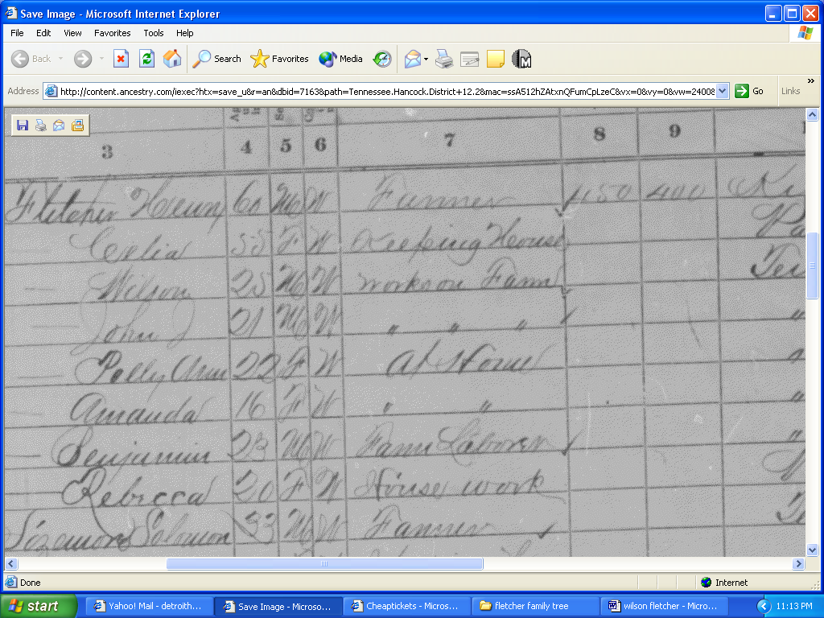

Rootsweb.com screenprint above shows Henry having someone in his household named Wilson.

http://ftp.rootsweb.com/pub/usgenweb/tn/hancock/census/1870/pg081a.txt (Note by Matt Fletcher This says Henry Fletcher was born in KY, not VA

LINE | Dwell Famil | LastName FirstName | Age S C | Occupation | Real Pers | BirthPlace | F F Mont Mont | A C C | D | E D | SNDX | REMARKS
=====|=============|=================================|===========|===============================|===========|================|===============|=======|===|=====|======|========
1 | 7 7 | Fletcher Henry | 60 M W | Farmer | 450 400 | Kentucky | | | | | F432 |
2 | 7 7 | Fletcher Celia | 55 F W | Keeping House | | Virginia | | X X | | | F432 |
3 | 7 7 | Fletcher Wilson | 25 M W | Works on Farm | | Tennessee | | | | | F432 |
4 | 7 7 | Fletcher John J. | 21 M W | Works on Farm | | Tennessee | | X X | | | F432 |
5 | 7 7 | Fletcher Polly Ann | 22 F W | at home | | Tennessee | | X | | | F432 |
6 | 7 7 | Fletcher Amanda | 16 F W | at home | | Tennessee | | X | | | F432 |
7 | 7 7 | Fletcher Benjamin | 23 M W | Farm Laborer | | Tennessee | Oct | X X | | | F432 |
8 | 7 7 | Fletcher Rebecca | 20 F W | House Work | | Virginia | Oct

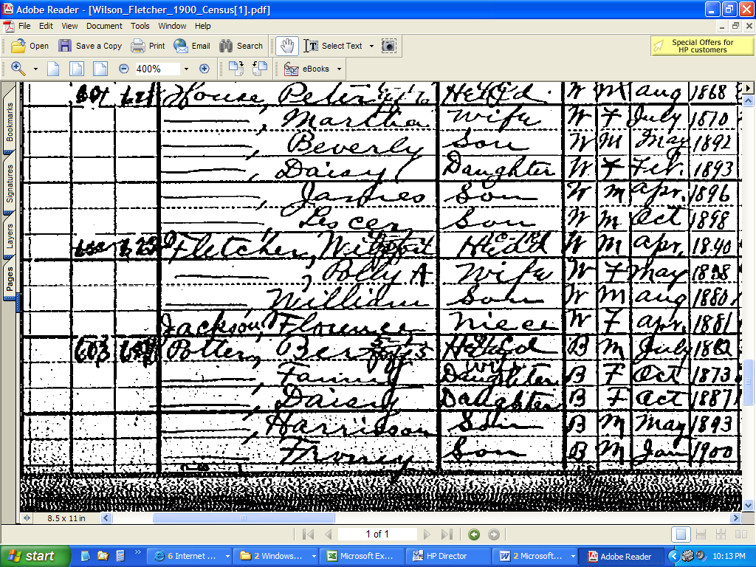

Screen print of 1900 Clay County KY census. Says Wilson has a son named William. It says “William here but the marriage license and headstone of “William” say W. M. Fletcher. Is this the same person or not????

William (my grandfather) links to Wilson and Wilson links to Henry in census documents. I can’t find anything linking Thomas to Henry. Florence Jackson, niece to Wilson is the grandmother or great grandmother of Francis Howard Hickey. - Matt Fletcher

Remind me to scan in the Marriage certificate of William and Myrtle and I will send it to you.

