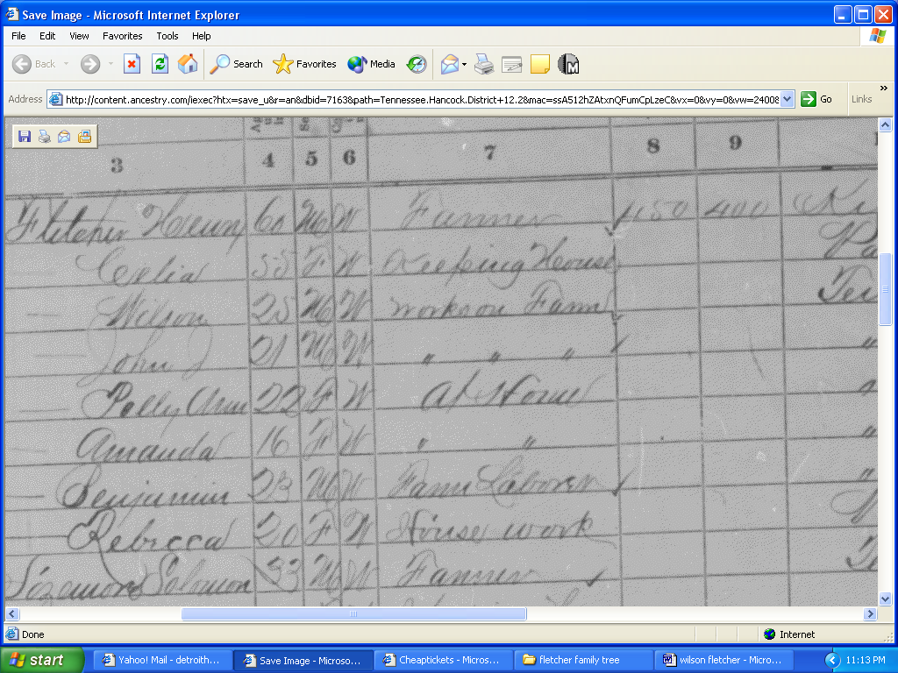

Wilson is the son of Henry. Is polly his wife or sister?

